**EXP NO: 06 DATE: 14-03-24**

**Aim:** To Create a simple cloud software application for Payroll Processing System using any Cloud Service Provider to demonstrate SaaS include the necessary fields such as Name of the employee, experience in present org, over all experience, basic pay, HRA, DA, TA, net pay, gross pay etc.

**Implementation:**

1.Go to Zoho.com and login/signup

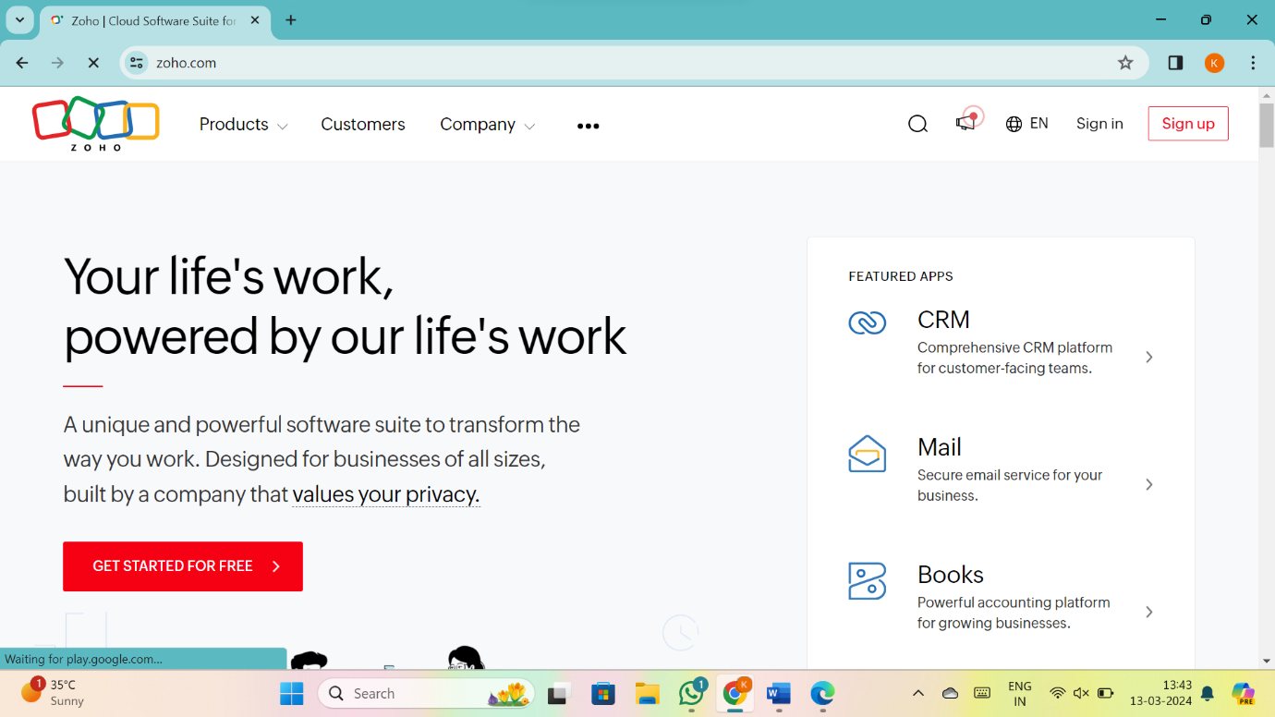

2.Go to Creator

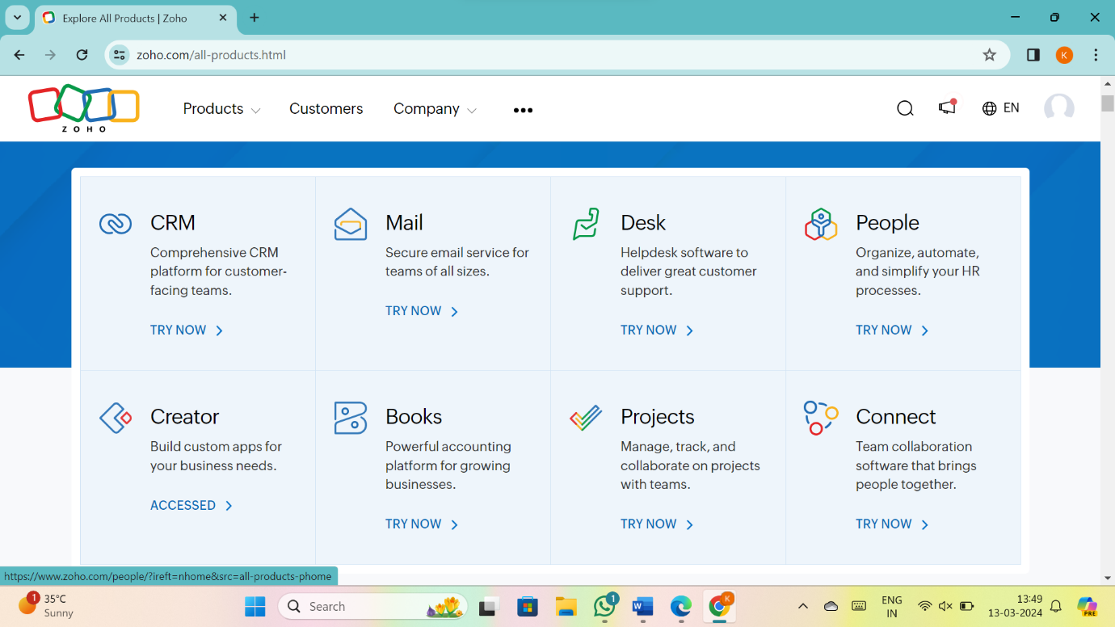

3. CREATE NEW APPLICATION

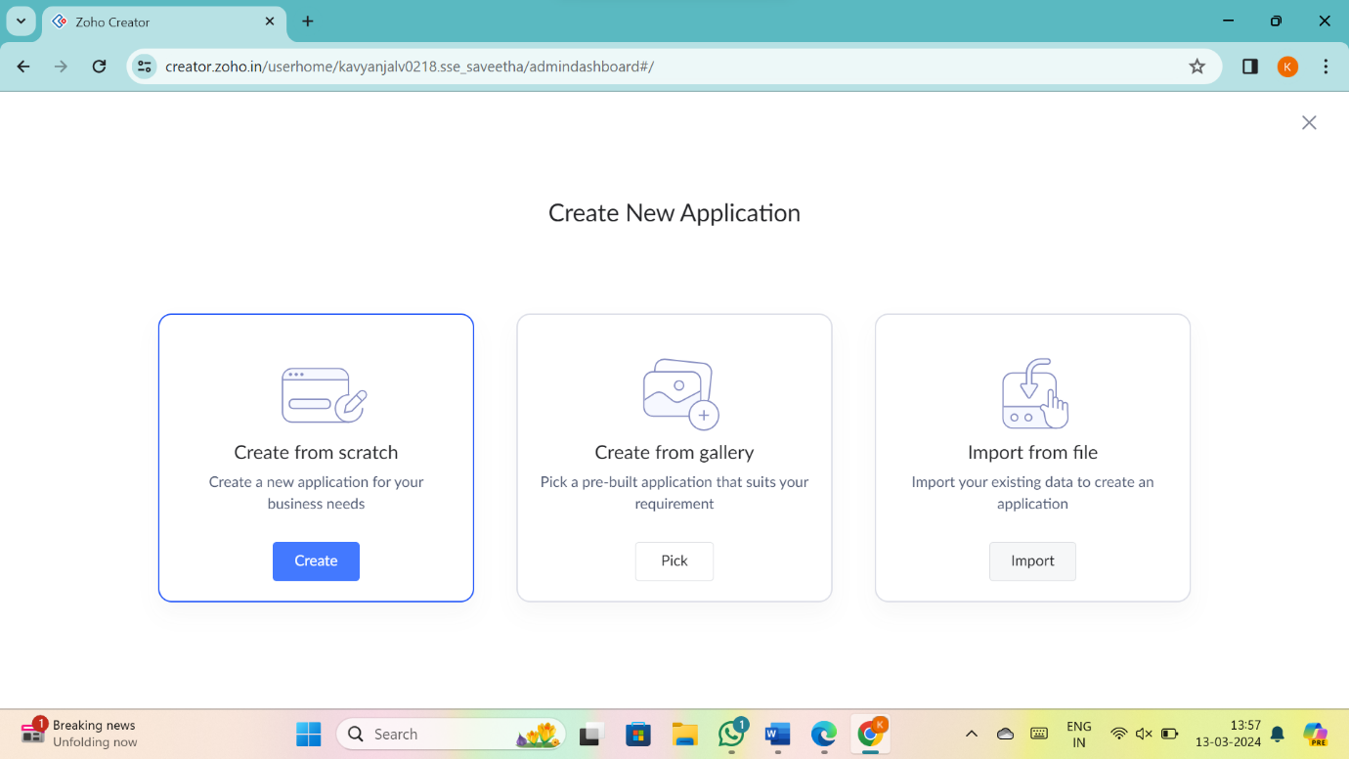

4.Give Application Name

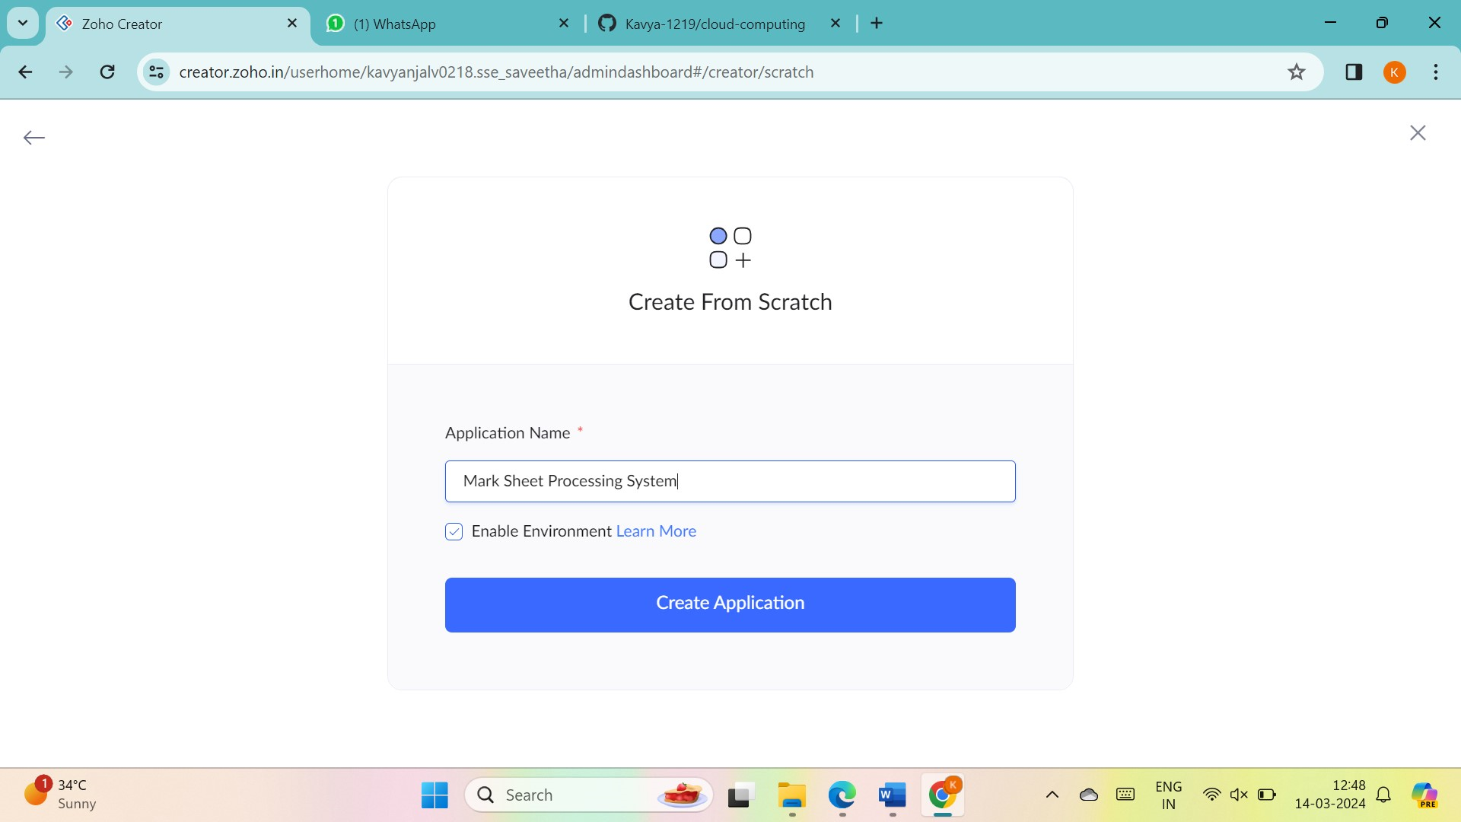

5.Create New Form

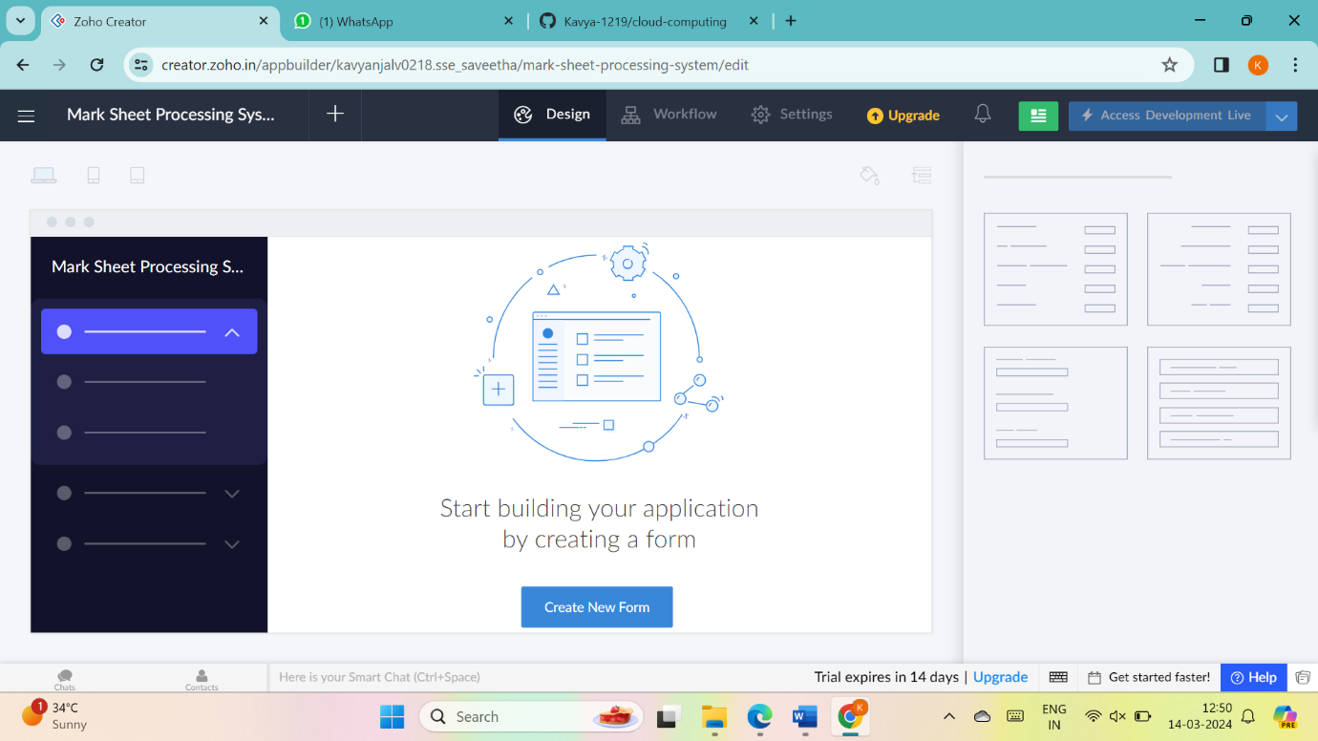

6.Select Form and give name

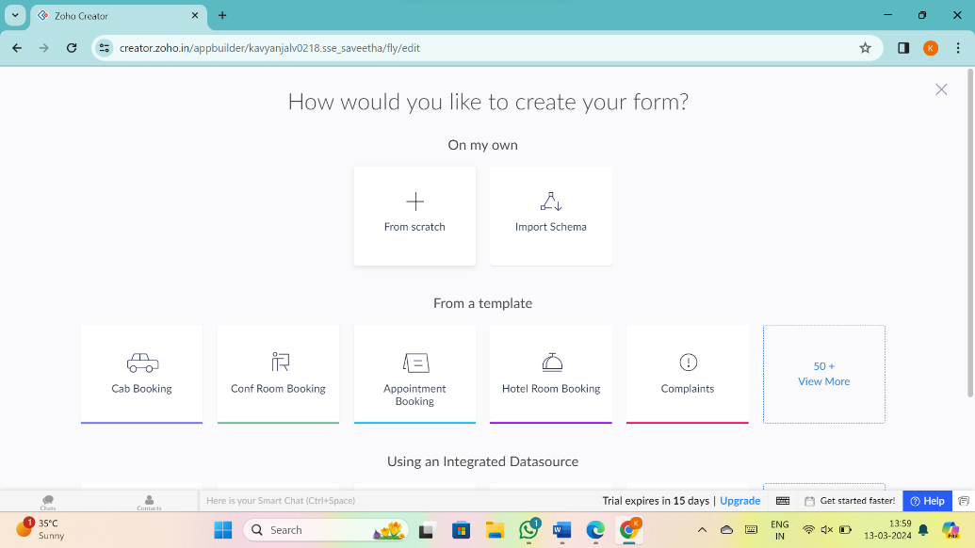

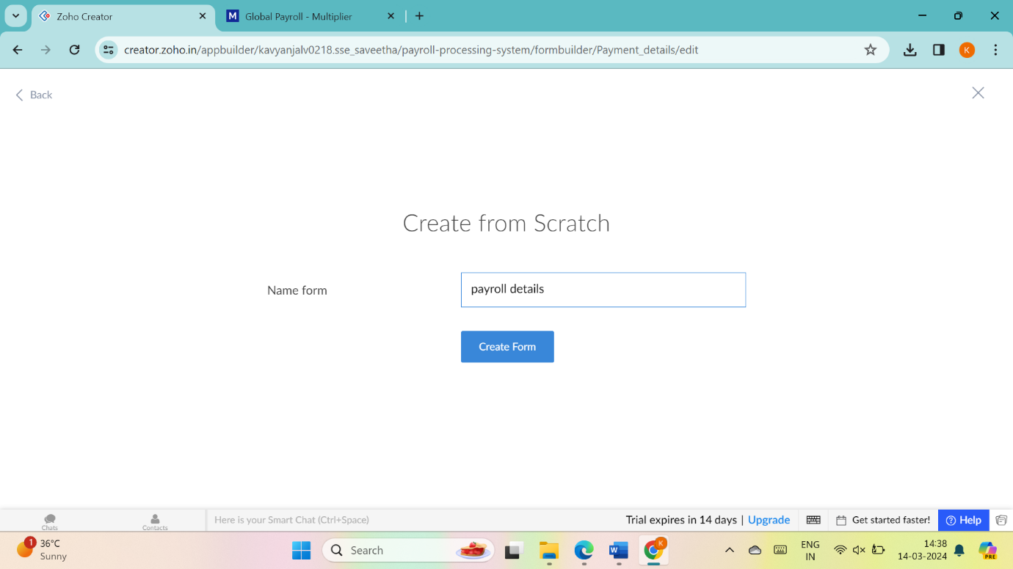

7.Drag necessary fields

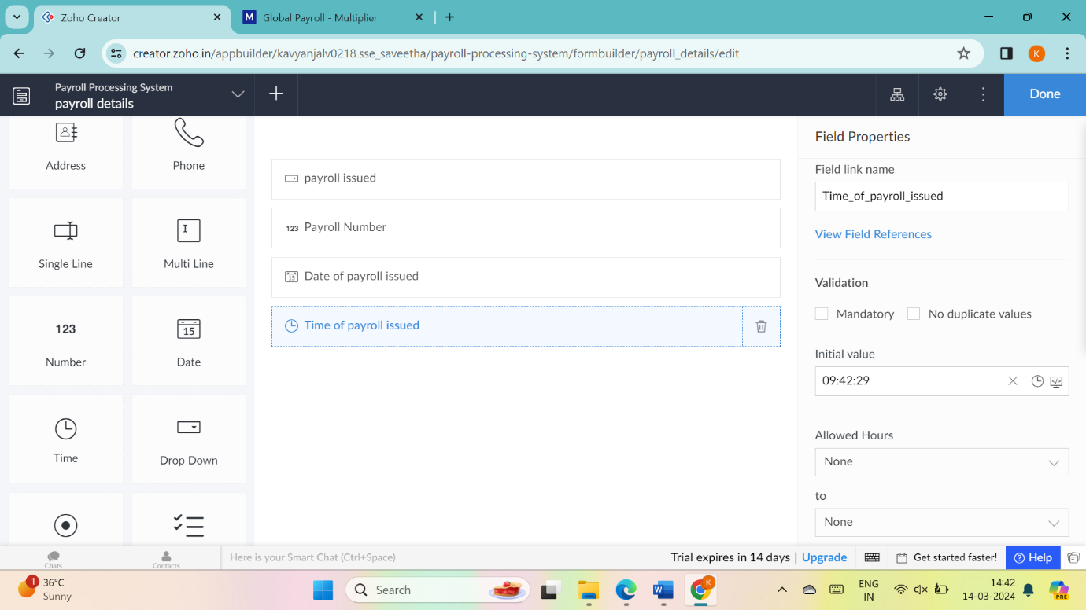

8.create new forms if necessary

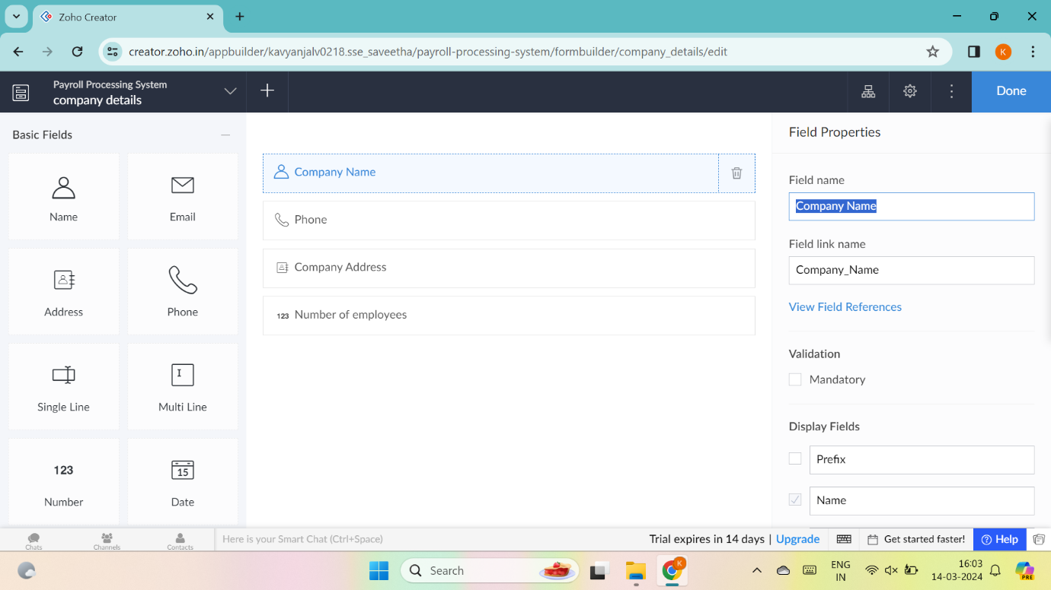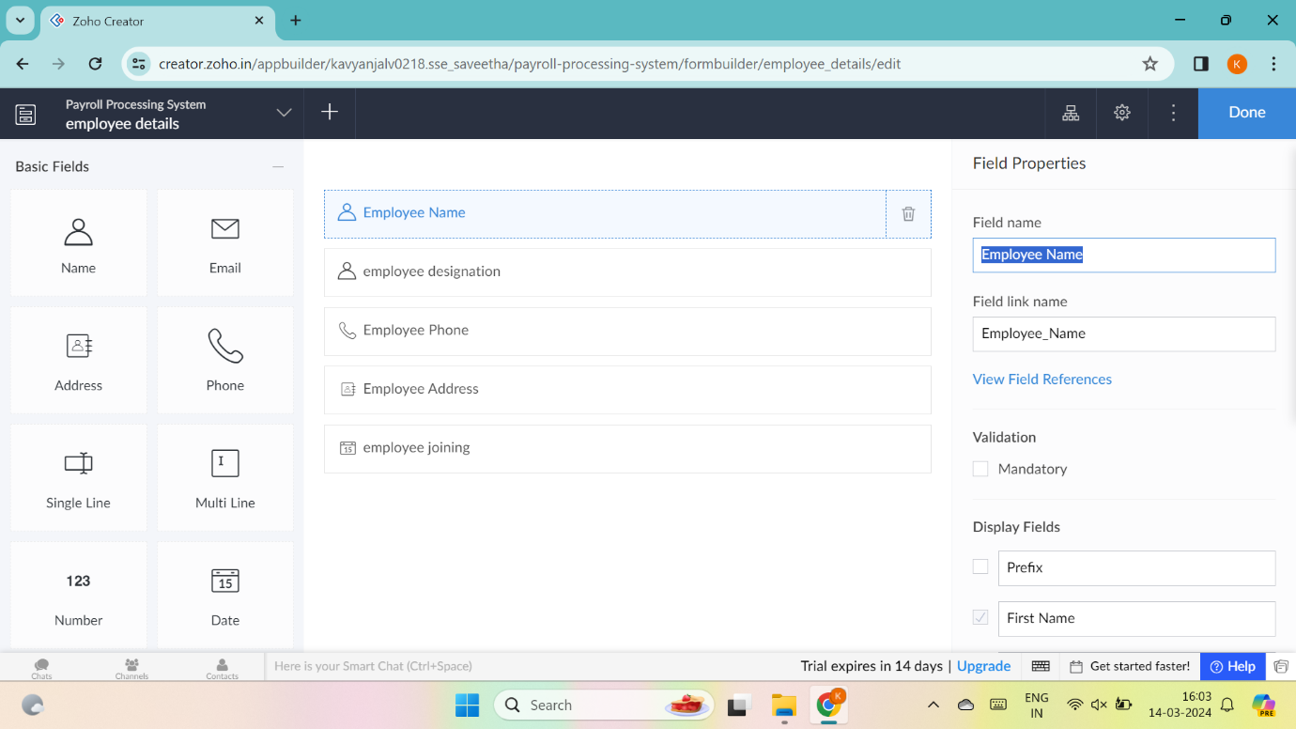

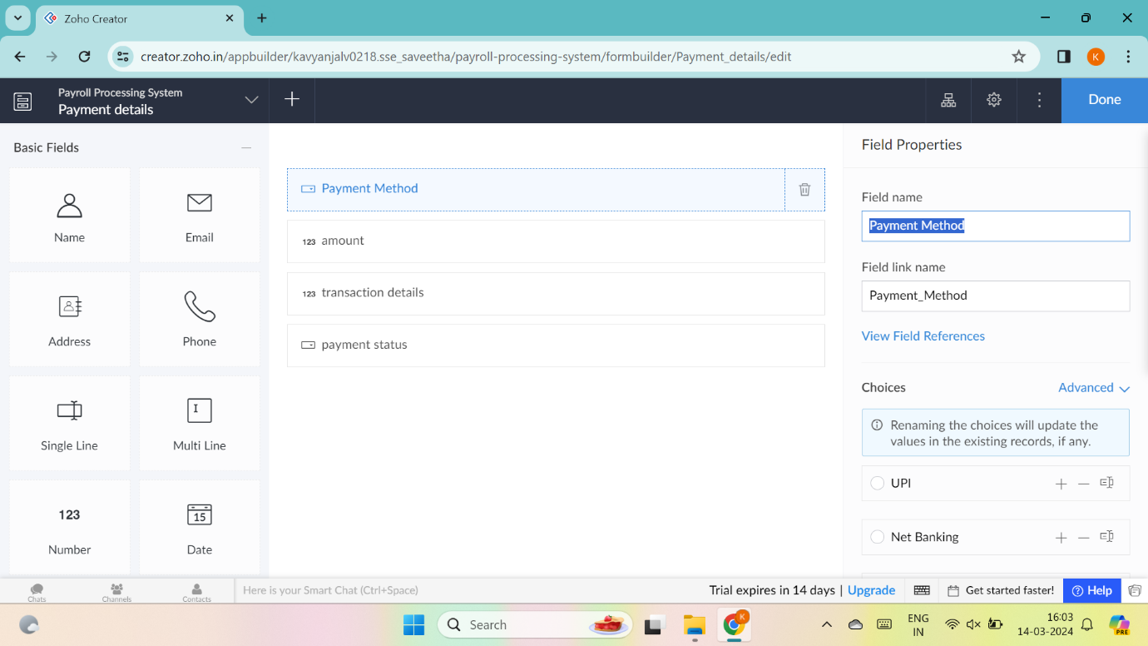

9.the software has been created

